**Ticket booking on Cleartrip**

1. Open [**http://www.Cleartrip.com**](http://www.Cleartrip.com) website.
2. A pop-up window opens, enter your mobile number.

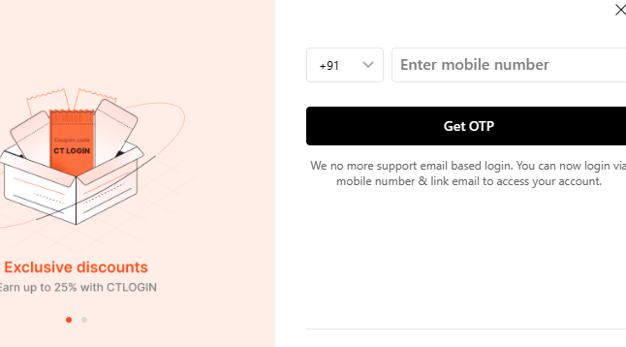

1. Enter OTP number sent to your registered mobile number.

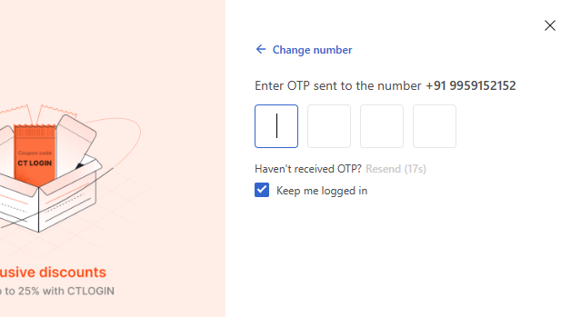

1. Enter your email id, click **Next** or **Skip** (if you don’t want to receive notifications).
2. It navigates to main page, on left pane, select mode of transport that is **flight** or **bus**.

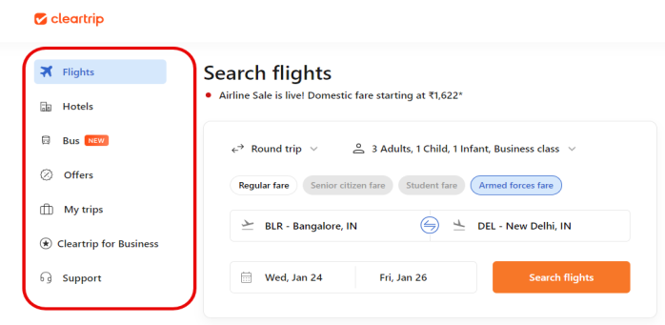

1. Select **Flights** if you want to travel by flight.
2. Select **One way** or **Round trip** (traveling from a starting point to a destination and then returning back to starting point).

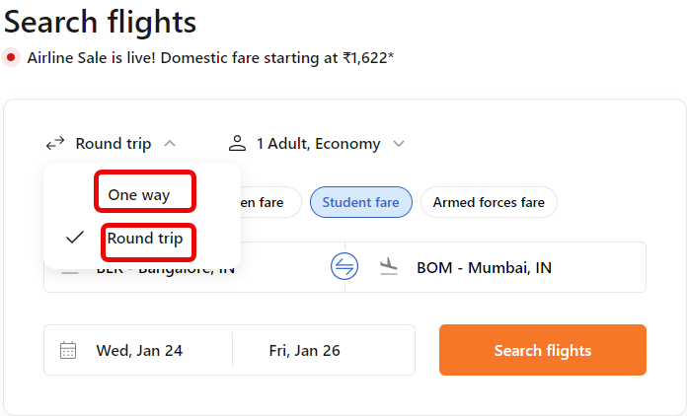

1. Select **Economy/Business class/First class/Premium economy**, accordingly ticket prices vary.
2. Select **Regular fare**, if you are traveling with **Adults, Children, Infants**.

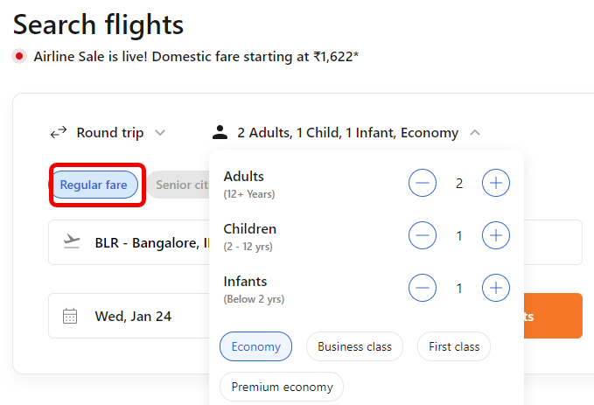

1. Select **Senior citizen fare**, if your age is above 60 years. You can add only adults.

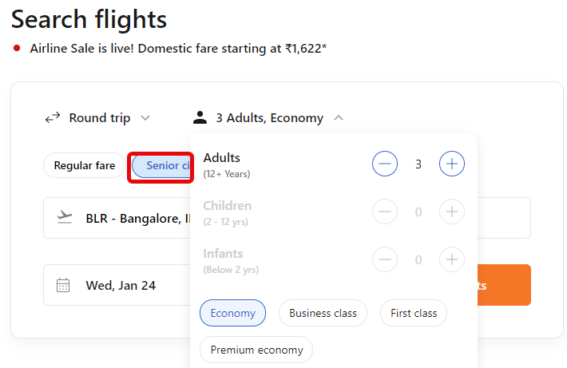

1. Select **Student fare** if you are above 12 years with valid id. You can add only adults.

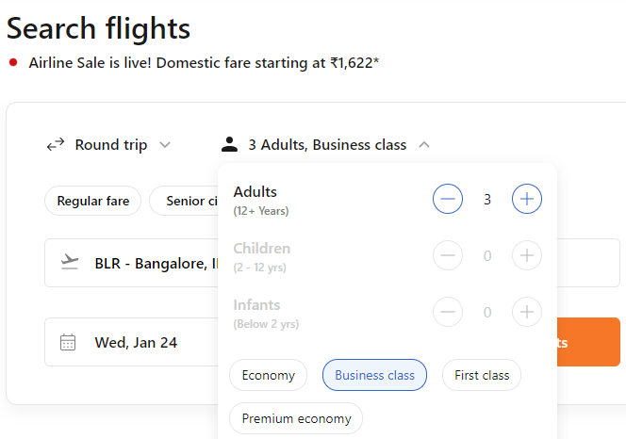

1. Select **Armed forces fare** if you are serving/retired armed forces personnel and also dependents can avail this offer. You can add adults, children and infants.

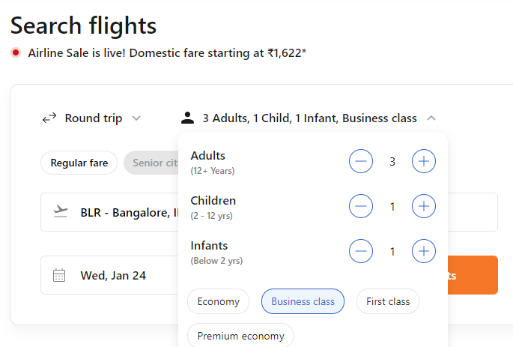

1. Select **Where from**, drop down list appears to select jumping-off point in your city.

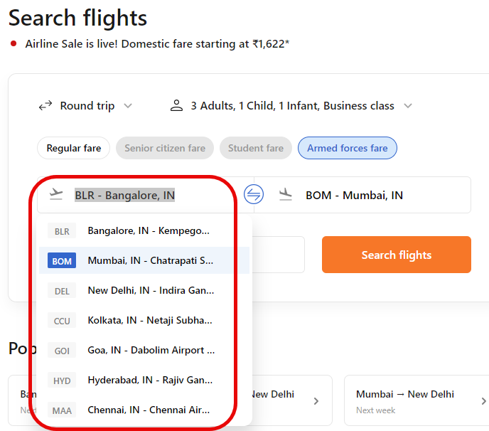

1. Select **Where to**, a drop down list appears to select the destination place.

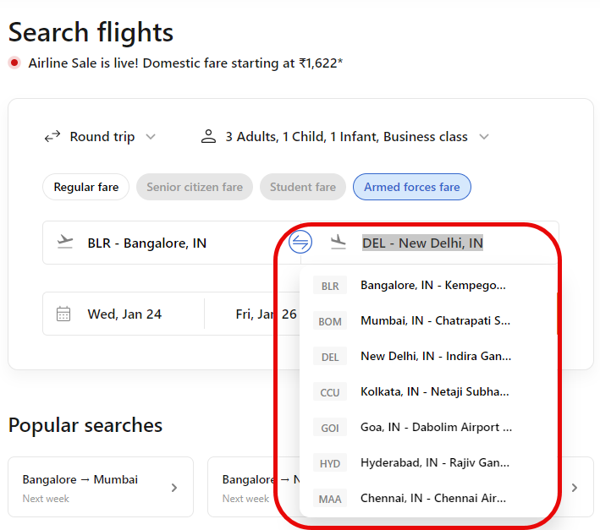

1. Select the **date** you want to travel.

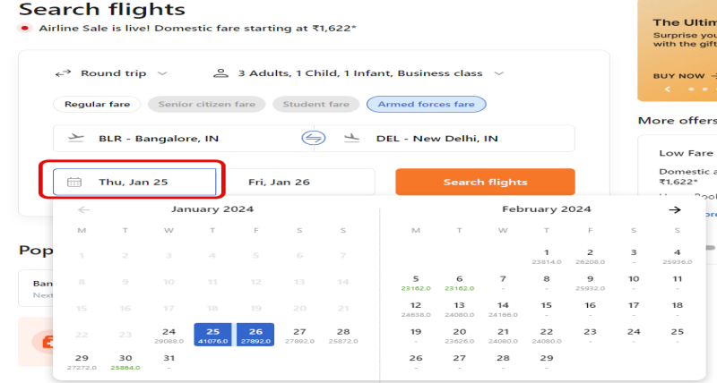

1. If it is a round trip, Select the **date** when you want to travel back.

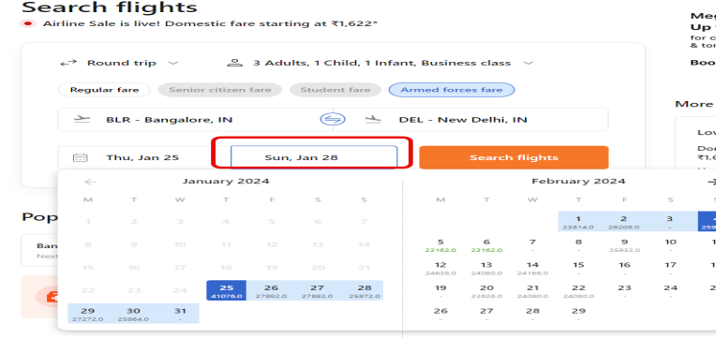

1. Now, click **Search flights**.
2. The next page shows the list of flights available.

* On the top, details of your journey are displayed.
* On the left pane, select stops, departure time from jumping-off point, and departure time from destination.
* Also select one way price, airlines, trip duration, and layover duration.
* On the right pane, click **Book now**.

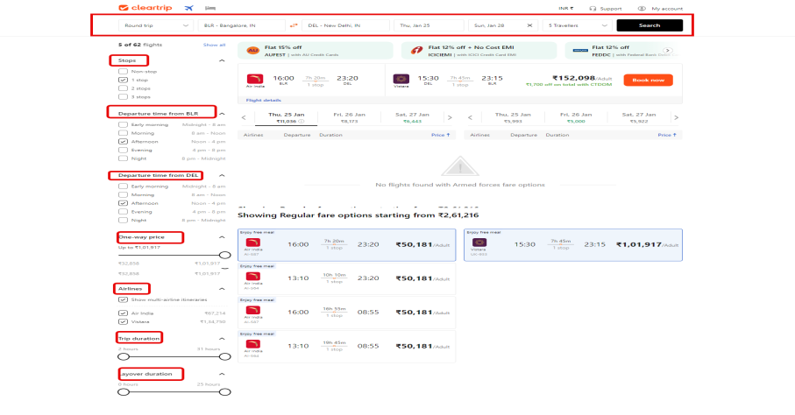

1. The next page displays review itinerary.

* Check cancellation policy and date change policy, in case you want to cancel the ticket or change the dates respectively.
* Check total price on right pane.
* Click **Continue**.

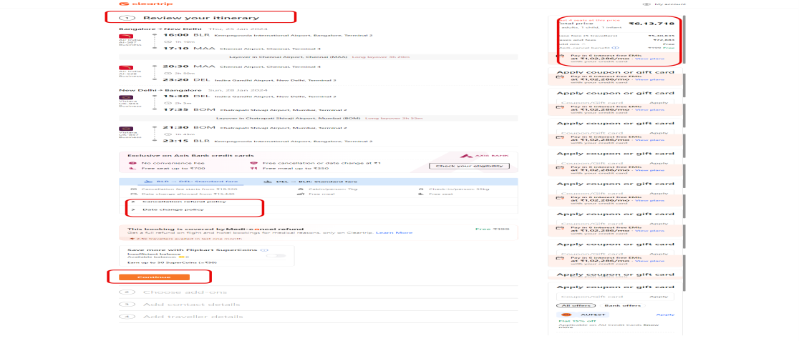

1. In the next page, add your mobile number and email id. Click **Continue**.
2. Select the mode of payment. Click **Continue**.
3. Online booking details are sent to your registered mobile number and email id. Click **Logout**.